Assignment 5
Problem Definition:- Searching for internships and entry-level roles is often a disorganized process. Students apply on multiple platforms, forget deadlines, and struggle to track statuses such as Applied, Under Review, Interview Scheduled, or Rejected.
The objective of a Job Application Tracker is to design a simple system that helps a student record job details, update progress, and receive basic reminders. This system improves clarity, reduces missed opportunities, and supports better planning during the early career phase.

Algorithm :-
START
1. Initialize an empty list called Applications.
2. Display menu:
1. Add new job application
2. Update application status
3. View all applications
4. Search by company name
5. Exit
3. Ask user for their choice.
4. IF choice = 1 THEN
a. Input Company Name
b. Input Job Role
c. Input Deadline Date
d. Set default Status = “Applied”
e. Add details to Applications list
ENDIF
5. IF choice = 2 THEN
a. Input Company Name
b. Search record in Applications list
c. If found, input new Status and update
ENDIF
6. IF choice = 3 THEN
a. Display all saved application records
ENDIF
7. IF choice = 4 THEN
a. Input search keyword
b. Display records matching company name
ENDIF
8. IF choice = 5 THEN
EXIT program
9. Repeat menu step until user chooses to Exit.
STOP
Flowchart
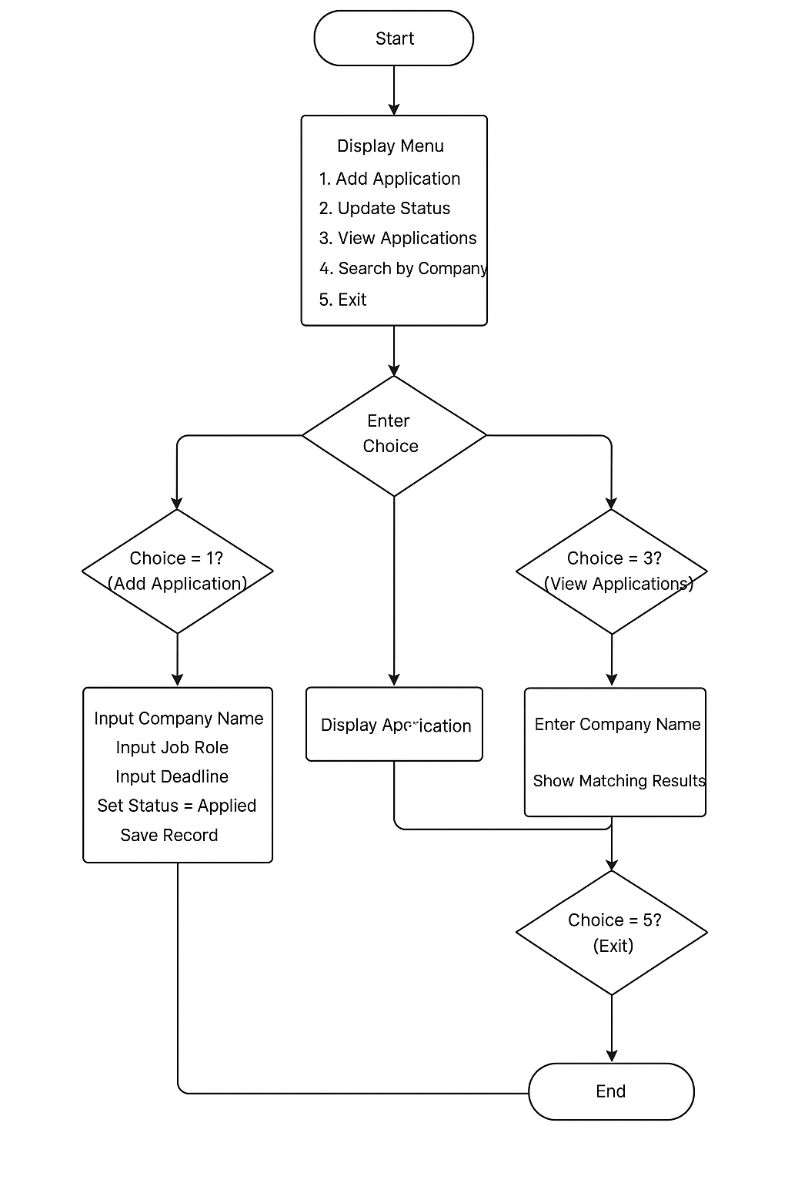
Linux & Automation Practice:-
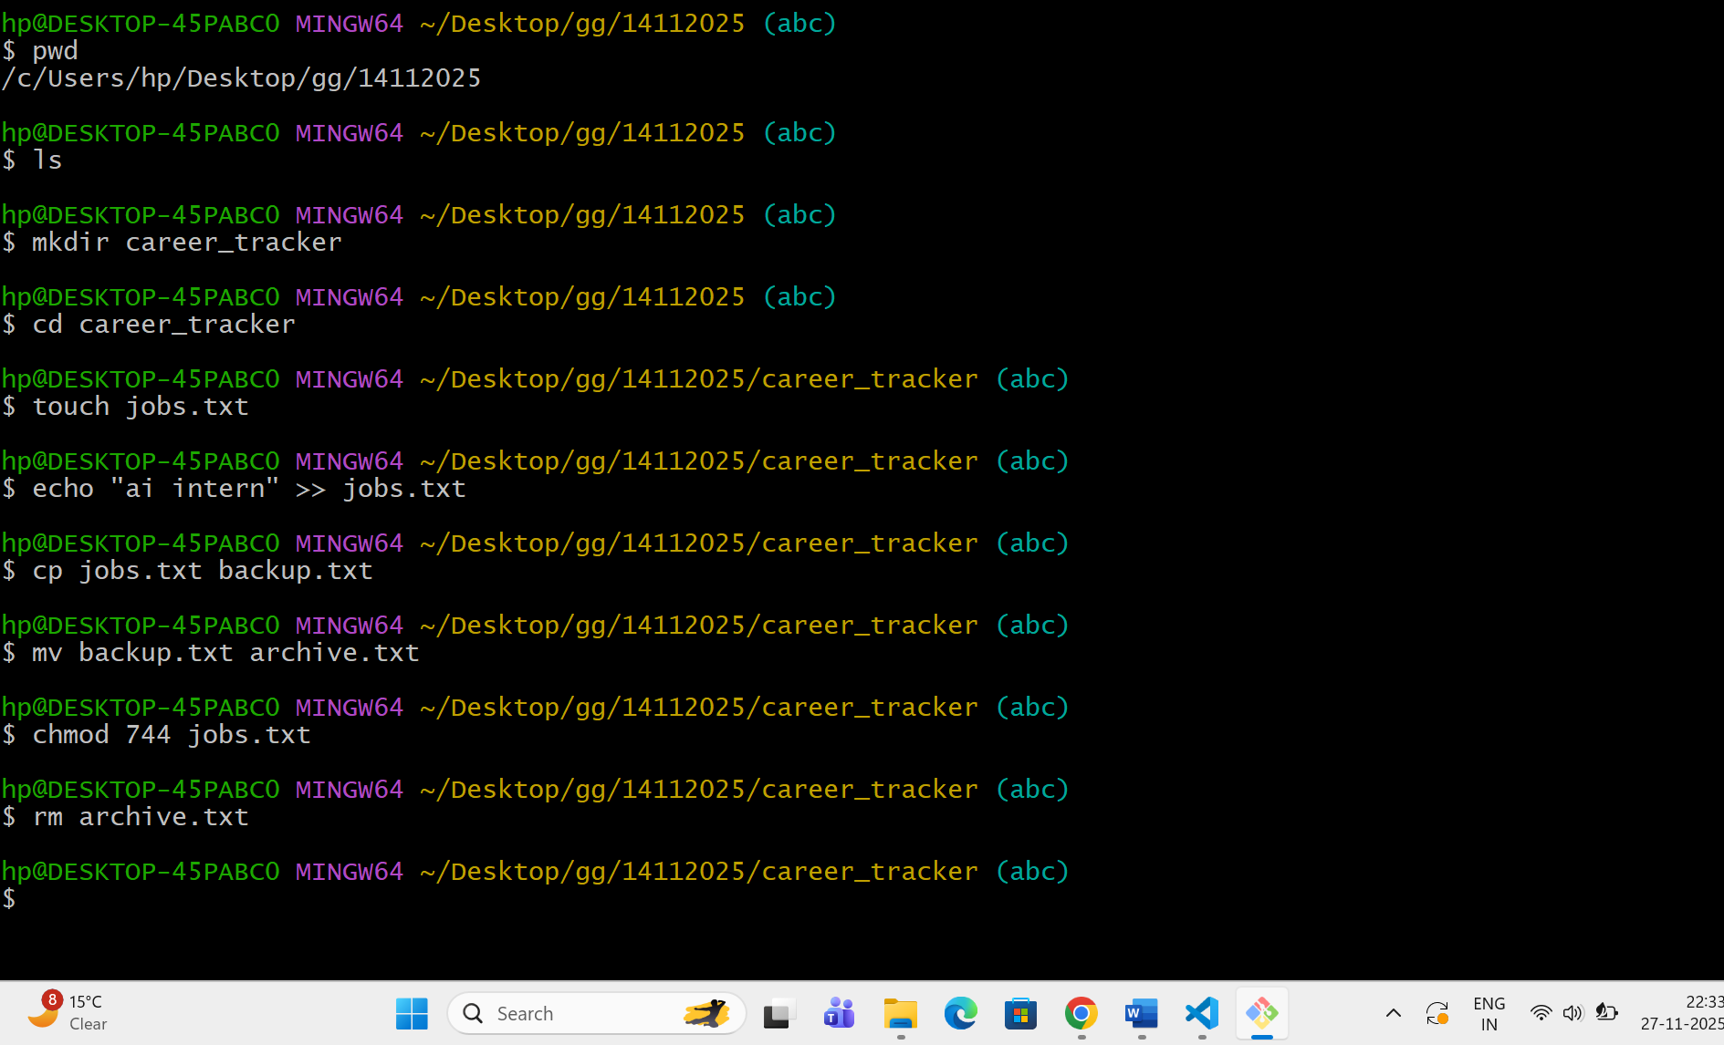
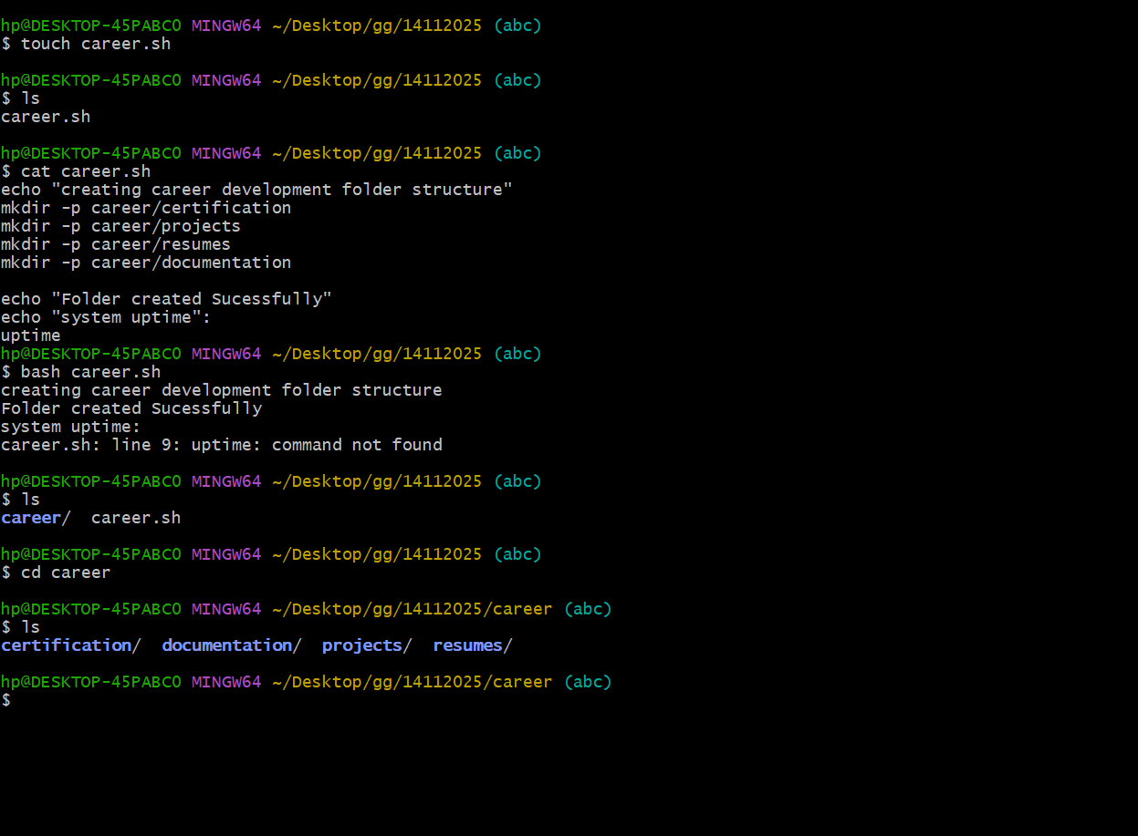

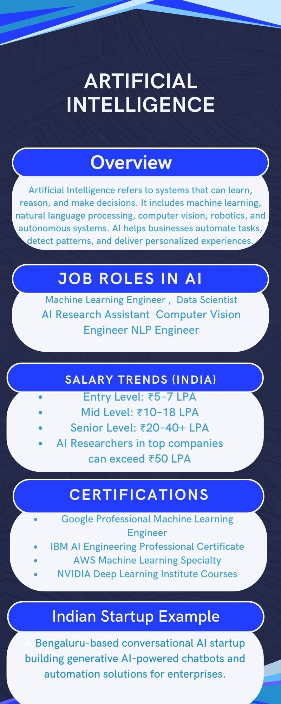

Career Planning & Professional Readiness:-
1. SMART Goals
Short-Term Goal (0–6 months)
I will complete a beginner-friendly Machine Learning course, practice Python daily, and build at least one small AI project (such as a classifier) to strengthen my foundational skills before the end of this semester.
Medium-Term Goal (6–18 months)
I will earn a recognized AI certification and participate in at least one hackathon to enhance my practical exposure, teamwork skills, and industry visibility.
Long-Term Goal (2–4 years)
I aim to secure an AI-focused internship followed by a full-time position as a Machine Learning Engineer by consistently building projects, contributing to open-source repositories, and developing strong mathematical and programming competencies.
2. Certification Research (Two Certifications)
Certification 1: IBM AI Engineering Professional Certificate
- Provider: Coursera + IBM
- Duration: 3–6 months (self-paced)
- Cost: Approximately ₹3,600/month
- Skills Covered: Supervised learning, unsupervised learning, deep learning, neural networks, TensorFlow, deployment basics
- Alignment: Helps achieve my short-term and medium-term goals by strengthening fundamentals and preparing me for real-world AI projects.
Certification 2: Google Professional Machine Learning Engineer
- Provider: Google Cloud
- Duration: 2–4 months preparation
- Cost: Exam fee approx. ₹12,000
- Skills Covered: ML model development, data pipelines, MLOps, deployment, real-world ML problem solving
- Alignment: Supports my long-term goal of becoming a Machine Learning Engineer and prepares me for industry-level workflows.
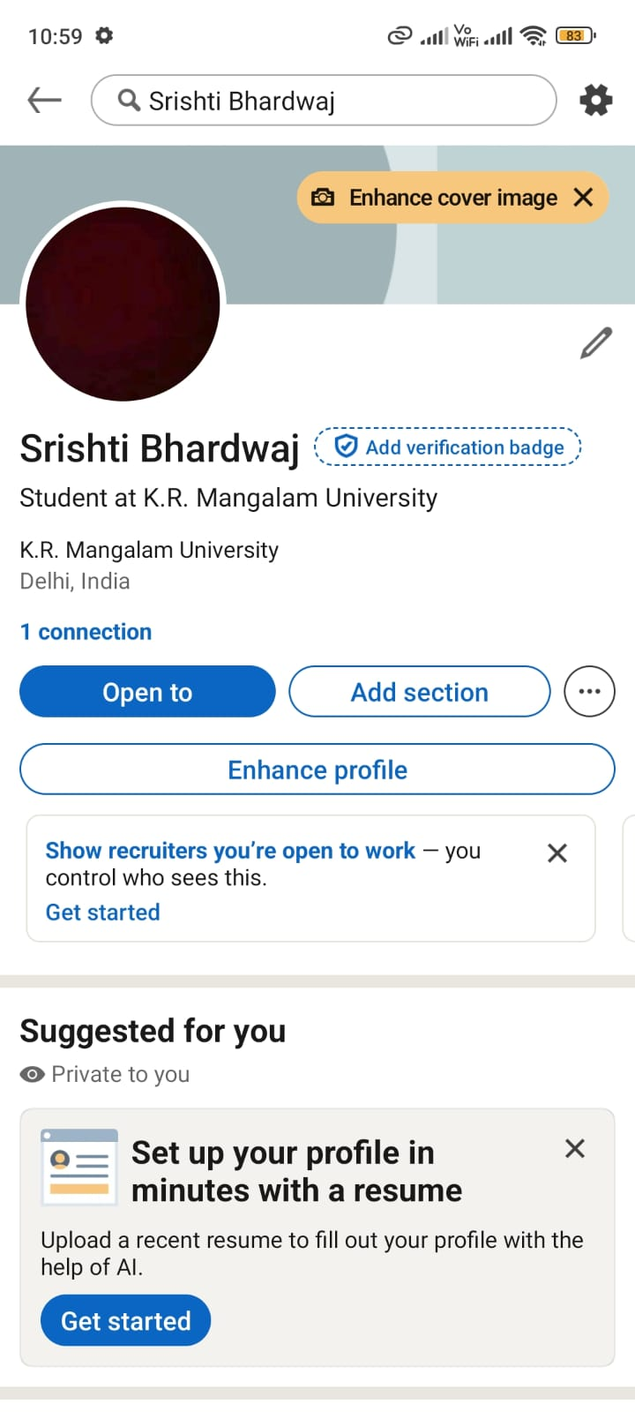
Linked in url https://www.linkedin.com/in/srishti-bhardwaj-38520a383?utm_source=share&utm_campaign=share_via&utm_content=profile&utm_medium=android_app
Profile Summary :
A first-year B.Tech CSE (AI & Robotics) student passionate about Artificial Intelligence, problem-solving, and applied machine learning. I enjoy building beginner-friendly models, participating in tech events, and exploring how AI transforms industries. I am actively developing my skills in Python, data analysis, and ML tools while preparing for relevant certifications.
Add skills:
- Python
- Machine Learning
- Data Structures

Hackathon / Contest / Open Source Plan
Event Chosen: Smart India Hackathon (SIH)
Preparation Plan:
- Identify problem statements related to AI/ML
- Form a team of 4–6 members
- Practice model building using small datasets
- Prepare presentation and prototype
- Study previous SIH winning solutions

Career Roadmap: Becoming an AI Professional
Building a successful career in Artificial Intelligence requires a thoughtful balance of strong fundamentals, consistent practice, and awareness of industry expectations. Over the next four years of my B.Tech program, I aim to develop myself into a well-rounded AI professional who understands both theoretical concepts and practical implementation. My journey begins with strengthening my command over programming, particularly Python, since it forms the backbone of most AI projects. During my first year, I plan to focus on improving my problem-solving skills through regular coding practice and by understanding basic machine learning algorithms. Alongside coursework, I intend to build small projects such as classification models, data visualizations, and automation tools. These initial steps will help me translate classroom learning into tangible outputs. In my second year, I aim to expand my exposure to intermediate AI concepts. This includes neural networks, deep learning, and natural language processing. To achieve this, I will enroll in a formal certification program such as IBM’s AI Engineering Professional Certificate. Completing a recognized certification will not only deepen my understanding but also make my profile more credible for future internships. At the same time, I plan to participate in at least one hackathon. Hackathons provide a fast-paced environment to test problem-solving abilities, collaborate with peers, and think creatively under pressure. Participating in events like SIH or internal college hackathons will help me understand real-world constraints and improve my teamwork skills. By the third year, I aim to shift my focus towards building large, end-to-end AI projects. These may include recommendation systems, sentiment analysis models, or computer vision applications. I also plan to upload all these projects on GitHub to maintain a strong online presence. During this phase, I want to contribute to open-source repositories that use AI libraries such as TensorFlow or PyTorch. Contributing even small bug fixes or documentation improvements will help me understand collaborative development practices and make me more confident in handling complex codebases. Around this time, I will also start preparing for the Google Professional Machine Learning Engineer certification. The exam requires strong understanding of ML workflows, deployment, and model evaluation, making it a valuable credential for industry roles. In my final year, the main priority will be to secure an internship at a company working in AI, machine learning, or data science. An internship will allow me to apply my skills to real business problems and gain professional experience under industry mentors. I intend to build a strong portfolio that demonstrates my growth through academics, certifications, projects, and hackathon participation. I will also update my LinkedIn profile regularly, connect with professionals, and attend webinars or workshops related to AI trends. Overall, my career roadmap is built on step-by-step progress, continuous learning, and practical application.

Reflection
Working on this assignment gave me the opportunity to think deeply about my long-term goals and the steps I need to take to build a successful career in Artificial Intelligence. The most challenging part was breaking everything into smaller tasks and sequencing them in a meaningful way. Designing the algorithm and flowchart reminded me how important structured thinking is, even outside programming. Exploring Linux commands and writing the bash script helped me understand how automation can simplify repetitive tasks.
The research section also improved my awareness of industry certifications and helped me see how these credentials fit into a broader career plan. Creating my smart goals made me more realistic about timelines, while the career roadmap allowed me to reflect on how I want to grow academically and professionally over the next few years. Overall, this assignment strengthened my planning skills and helped me see the importance of consistency, practice, and clear direction in building a future in AI.

